Chapter 4, Solution 23

If we transform the voltage source, we obtain the circuit below.

8

10 6 3 5A
3A

3//6 = 2-ohm. Convert the current sources to voltages sources as shown below.
10 8 2

+ +
10V
30V - -

Applying KVL to the loop gives
I = 1 A

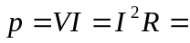 8 W

